Colorectal Cancer Detection Using Pre-Trained Ensemble
Algorithms

¹Ms.Shaik Sharmila Assistant Professor,
Department of Computer Science and Engineering, Sridevi Women's Engineering College, Wipro V.N.Pally, Gachibowli, Hyderabad West IT Corridor, R.R. District-500 075,Email:shaiksharmila.cse@gmail.com
²Patkuri Nandini
Student, Department of Computer Science and Engineering, Sridevi Women's Engineering College, Wipro V.N. Pally, Gachibowli, Hyderabad West IT Corridor, R.R. District-500 075

³Sanjana Chedudupu,
Student, Department of Computer Science and Engineering, Sridevi Women's Engineering College, Wipro V.N. Pally, Gachibowli, Hyderabad West IT Corridor, R.R. District-500 075

⁴Devasoth Nikitha, Student, Department of Computer Science and Engineering, Sridevi Women's Engineering College, Wipro V.N. Pally, Gachibowli, Hyderabad West IT Corridor, R.R. District-500 075

Abstract-- Colorectal cancer is one of the leading causes of cancer-related mortality worldwide, and early detection plays a critical role in improving patient survival rates. Recent advancements in artificial intelligence and medical imaging have enabled the development of automated diagnostic systems that assist clinicians in detecting cancer at early stages. This study proposes a colorectal cancer detection framework based on pre-trained ensemble algorithms to enhance classification accuracy and robustness. The proposed approach leverages multiple pre-trained deep learning models to extract discriminative features from colorectal medical images, which are then combined using an ensemble strategy to improve predictive performance. Transfer learning is employed to utilize knowledge from large-scale datasets, reducing training time and improving model generalization. The ensemble mechanism integrates the strengths of individual models and mitigates their limitations, resulting in more reliable detection outcomes. Experimental evaluation demonstrates that the proposed method achieves superior accuracy, precision, recall, and F1-score compared to individual baseline models. The results indicate that the integration of pre-trained models through ensemble learning can significantly enhance colorectal cancer detection and support clinical decision-making. The proposed framework provides a scalable and efficient solution for computer-aided diagnosis in colorectal cancer screening and early detection.
Keywords Colorectal Cancer Detection, Deep Learning, Transfer Learning, Ensemble Learning, Pre-trained Models, Medical Image Analysis, Computer-Aided Diagnosis, Classification Algorithms.
- INTRODUCTION
Colorectal cancer (CRC) is one of the most common and life-threatening cancers worldwide, contributing significantly to global cancer-related mortality. Early detection plays a crucial role in improving treatment outcomes and patient survival rates. Traditional diagnostic methods such as colonoscopy, biopsy, and manual interpretation of medical images are widely used for detecting colorectal abnormalities; however, these procedures are time-consuming and highly dependent on clinical expertise. In recent years, advancements in artificial intelligence (AI) and machine learning (ML) have enabled the development of computer-aided diagnostic systems that assist clinicians in detecting cancer at earlier stages with improved accuracy and efficiency.
Deep learning techniques, particularly convolutional neural networks (CNNs), have demonstrated strong performance in medical image classification and disease detection tasks. Pre-trained models combined with transfer learning allow the extraction of high-level features from medical images even when limited training data are available. However, single-model approaches may suffer from performance limitations due to variations in datasets and model bias. To address this issue, ensemble learning techniques combine multiple pre-trained models to enhance prediction accuracy and robustness. Therefore, this study proposes a colorectal cancer detection framework using pre-trained ensemble algorithms to improve classification performance and support reliable computer-aided diagnosis in colorectal cancer screening.
- Problem Statement
Colorectal cancer remains a major health challenge due to its high incidence and mortality rates, particularly when the disease is detected at advanced stages. Traditional diagnostic methods such as colonoscopy and manual interpretation of medical images are time-consuming, require specialized expertise, and may be prone to human error when analyzing large volumes of data. Although machine learning and deep learning techniques have been applied for cancer detection, many existing systems rely on single-model approaches that may suffer from limited accuracy, overfitting, and poor generalization across different datasets. Therefore, there is a need for an efficient and reliable automated system that can improve detection accuracy and robustness. This study addresses this challenge by proposing a colorectal cancer detection approach based on pre-trained ensemble algorithms, aiming to enhance classification performance and assist healthcare professionals in early and accurate diagnosis.
- Objectives
- To develop an automated system for detecting colorectal cancer using pre-trained deep learning models.
- To utilize transfer learning techniques to extract meaningful features from colorectal medical images and improve detection efficiency.
- To implement ensemble algorithms by combining multiple pre-trained models to enhance classification accuracy and robustness.
- To evaluate the performance of the proposed ensemble framework using metrics such as accuracy, precision, recall, and F1-score.
- To assist healthcare professionals by providing a reliable computer-aided diagnostic system for early and accurate colorectal cancer detection.
- Challenges in Existing Algorithms:
- Limited Accuracy with Single Models:
Many existing colorectal cancer detection systems rely on a single machine learning or deep learning model, which may not capture all relevant features from medical images, leading to lower detection accuracy.
- Overfitting Issues:
Traditional algorithms often suffer from overfitting when trained on limited medical datasets, causing poor performance when applied to new or unseen data.
- High Dependence on Large Datasets:
Several deep learning models require large labeled datasets for effective training. However, obtaining large, high-quality annotated medical datasets is difficult and time-consuming.
- Computational Complexity:
Some advanced deep learning algorithms require high computational resources and long training times, making them difficult to deploy in real-time clinical environments.
- Poor Generalization Capability:
Existing models may perform well on specific datasets but fail to generalize across different imaging conditions, hospitals, or patient populations, reducing their reliability in practical medical applications.
- Motivation
Colorectal cancer is a major global health concern, and its early detection is crucial for improving patient survival and reducing mortality rates. However, traditional diagnostic methods often rely on manual examination of medical images, which can be time-consuming and prone to human error. With the increasing availability of medical imaging data, there is a growing need for intelligent and automated systems that can assist healthcare professionals in accurate and efficient diagnosis. Recent advancements in deep learning and transfer learning have shown promising results in medical image analysis, but individual models may still face limitations in terms of accuracy and robustness. This motivates the development of a colorectal cancer detection system based on pre-trained ensemble algorithms, which can leverage the strengths of multiple models to achieve improved detection performance and support reliable computer-aided diagnosis.

Overview
This study presents a colorectal cancer detection framework based on pre-trained ensemble algorithms to improve the accuracy and reliability of automated medical image classification. The proposed system utilizes pre-trained deep learning models to extract meaningful features from colorectal medical images through transfer learning. These models are combined using an ensemble learning approach to leverage the strengths of multiple classifiers and enhance prediction performance. The framework includes stages such as data preprocessing, feature extraction using pre-trained networks, ensemble-based classification, and performance evaluation using standard metrics such as accuracy, precision, recall, and F1-score. By integrating multiple models, the proposed approach aims to reduce the limitations of single-model systems and provide a more robust computer-aided diagnostic solution for early colorectal cancer detection.

- LITERATURE SURVEY
Several studies have explored the application of machine learning and deep learning techniques for the detection and classification of colorectal cancer using medical imaging data. In recent years, convolutional neural networks (CNNs) have become widely used due to their ability to automatically extract hierarchical features from complex medical images. Researchers have applied deep learning architectures such as VGGNet, ResNet, and Inception networks for colorectal cancer detection and achieved significant improvements compared to traditional image processing techniques. For instance, some studies utilized transfer learning with pre-trained CNN models to classify colorectal histopathological images, demonstrating improved accuracy even with limited datasets. Other research efforts have focused on using image preprocessing techniques such as normalization, segmentation, and feature extraction to enhance the quality of medical images before classification. Additionally, machine learning algorithms such as Support Vector Machines (SVM), Random Forest (RF), and k-Nearest Neighbors (KNN) have been employed for cancer detection tasks by utilizing extracted features from medical images. However, many of these approaches rely on single classifiers, which may not fully capture the complex patterns present in medical datasets and may lead to limited generalization performance. To overcome these limitations, ensemble learning techniques have been introduced, where multiple models are combined to produce more accurate and robust predictions. Ensemble methods such as bagging, boosting, and stacking have shown promising results in improving classification accuracy and reducing overfitting in medical image analysis. Recent studies have also explored hybrid approaches that integrate deep learning feature extraction with machine learning classifiers to enhance detection performance. Despite these advancements, challenges such as data imbalance, computational complexity, and variability in medical image quality still remain. Therefore, integrating pre-trained deep learning models with ensemble algorithms provides a promising direction for improving colorectal cancer detection systems by leveraging the strengths of multiple models and achieving more reliable diagnostic outcomes.

Proposed Methodology
The proposed methodology aims to develop an automated colorectal cancer detection system using pre-trained ensemble algorithms to improve classification accuracy and reliability. Initially, the colorectal medical image dataset undergoes preprocessing steps such as image resizing, normalization, and noise removal to enhance image quality and ensure consistency in the input data. After preprocessing, transfer learning is applied using multiple pre-trained deep learning models to extract high-level and discriminative features from the medical images. These extracted features are then combined using an ensemble learning approach, where the predictions from multiple models are aggregated to produce a final classification result. The ensemble technique helps in reducing the limitations of individual models and improves the robustness of the system. Finally, the performance of the proposed framework is evaluated using standard evaluation metrics such as accuracy, precision, recall, and F1-score to measure its effectiveness in detecting colorectal cancer. This methodology aims to provide an efficient computer-aided diagnostic system that supports early and reliable colorectal cancer detection.
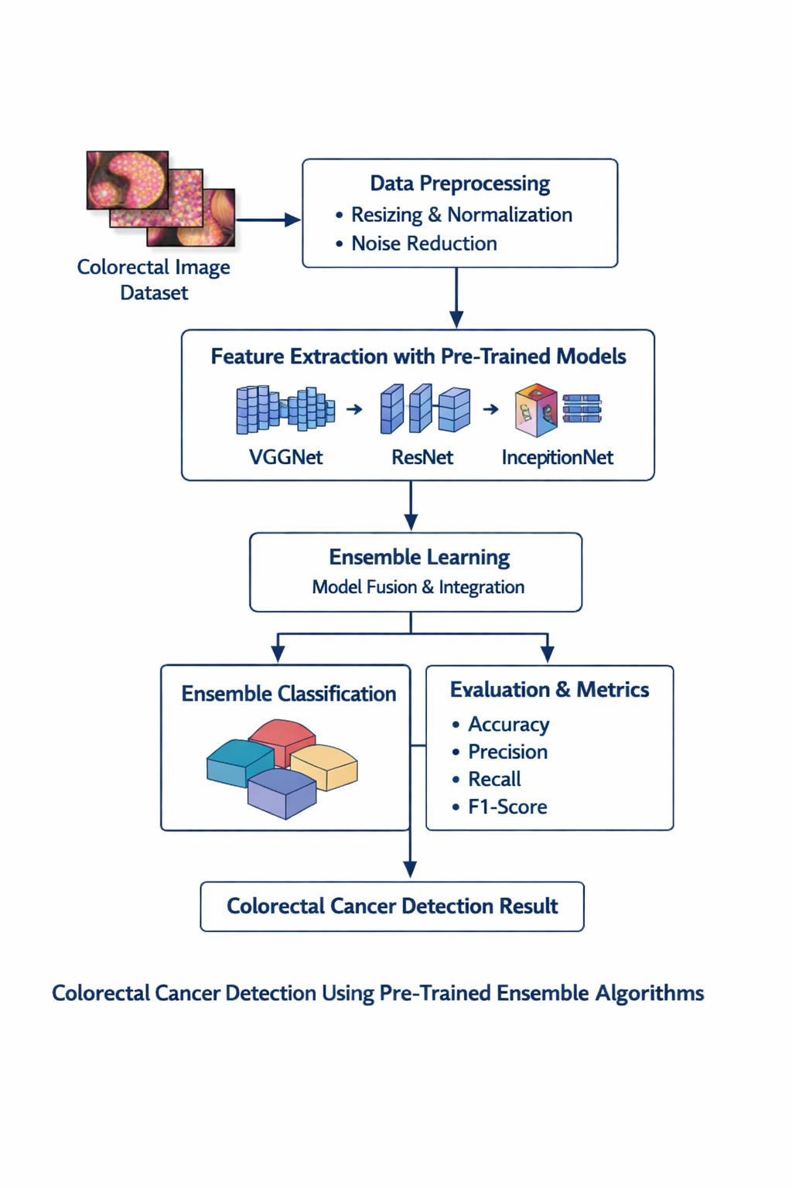
Fig. 1. Workflow
The workflow diagram illustrates the proposed system for colorectal cancer detection using pre-trained ensemble algorithms. Initially, a colorectal image dataset is collected as the input for the system. These images undergo data preprocessing, which includes operations such as resizing, normalization, and noise reduction to improve image quality and ensure uniform input for the models. After preprocessing, the system performs feature extraction using pre-trained deep learning models such as VGGNet, ResNet, and InceptionNet through transfer learning, enabling the extraction of meaningful and discriminative features from medical images. The extracted features from these models are then combined through an ensemble learning approach, where multiple models are integrated to enhance prediction reliability. This ensemble mechanism produces a final classification result, which determines whether the image indicates colorectal cancer or not. Finally, the performance of the system is evaluated using standard metrics such as accuracy, precision, recall, and F1-score, providing a comprehensive assessment of the model’s effectiveness in detecting colorectal cancer.

B. Algorithm
• Input:
•D = Colorectal medical image dataset
•L = Corresponding image labels (Cancer / Non-Cancer)
• Output:
•Predicted colorectal cancer classification result
• Begin
• 1. Load colorectal medical image dataset D and corresponding labels L
• 2. For each image Ii in dataset D do
a. Resize image to a fixed dimension
b. Normalize pixel values
c. Remove noise and enhance image quality
d. Store preprocessed image Pi
End For
• 3. Split the dataset into:
a. Training set
b. Validation set
c. Testing set
• 4. Initialize pre-trained deep learning models
a. VGGNet
b. ResNet
c. InceptionNet
• 5. For each preprocessed image Pi do
a. Input Pi into VGGNet and extract feature vector Fi₁
b. Input Pi into ResNet and extract feature vector Fi₂
c. Input Pi into InceptionNet and extract feature vector Fi₃
d. Combine extracted features to form feature vector Xi
End For
• 6. Construct feature matrix X using all extracted feature vectors Xi
• 7. Train individual classifiers using the training set
a. Train VGGNet classifier
b. Train ResNet classifier
c. Train InceptionNet classifier
• 8. Apply ensemble learning technique
a. Combine predictions from all models
b. Perform model fusion using voting or averaging method
c. Generate final prediction
• 9. Validate the ensemble model using validation dataset
a. Tune model parameters
b. Select best-performing ensemble configuration
• 10. Test the final model using testing dataset
a. Predict colorectal cancer labels
b. Compare predicted labels with actual labels
• 11. Evaluate model performance using metrics
a. Accuracy
b. Precision
c. Recall
d. F1-Score
• 12. For a new medical image Inew do
a. Preprocess the input image
b. Extract features using pre-trained models
c. Apply ensemble classification
d. Output predicted result (Cancer / Non-Cancer)
End For
• End

C. Experimental Setup
The experimental setup for the proposed colorectal cancer detection system is designed to evaluate the effectiveness of pre-trained ensemble algorithms in medical image classification. A colorectal medical image dataset is utilized as the primary input for the system, containing labeled images representing cancerous and non-cancerous conditions. The dataset undergoes several preprocessing steps, including image resizing, normalization, and noise reduction, to ensure consistent input quality and improve model performance. The preprocessed dataset is divided into training, validation, and testing subsets to enable proper model training and unbiased evaluation. Transfer learning is employed by utilizing pre-trained deep learning architectures such as VGGNet, ResNet, and InceptionNet, which are capable of extracting high-level features from medical images. These models are fine-tuned using the training dataset to adapt them specifically for colorectal cancer detection tasks.
After feature extraction, an ensemble learning strategy is applied to combine the predictions from the multiple pre-trained models in order to improve classification accuracy and robustness. Transfer learning is employed by utilizing pre-trained deep learning architectures such as VGGNet, ResNet, and InceptionNet, which are capable of extracting high-level features from medical images. The ensemble method integrates the outputs of individual models through techniques such as voting or averaging to produce the final prediction. The performance of the proposed framework is evaluated using standard classification metrics including accuracy, precision, recall, and F1-score, which provide a comprehensive assessment of the model’s effectiveness. The experiments are conducted using a deep learning framework such as TensorFlow or PyTorch in a Python-based environment with appropriate computational resources. This experimental setup enables systematic evaluation of the proposed approach and demonstrates the advantages of using pre-trained ensemble algorithms for reliable and efficient colorectal cancer detection.

IV. Results and Discussions

A.Dataset

A. Dataset
The dataset used in this study consists of colorectal medical images collected from publicly available medical imaging repositories and research datasets related to colorectal cancer detection. The dataset contains labeled images representing both cancerous and non-cancerous colorectal tissue samples, which are used to train and evaluate the proposed detection model. These images may include colonoscopy images or histopathological images that capture the structural characteristics of colorectal tissues. Before model training, the dataset undergoes preprocessing steps such as image resizing, normalization, and noise reduction to ensure uniformity and improve feature extraction. The prepared dataset is then divided into training, validation, and testing subsets to enable effective model learning and unbiased performance evaluation. This dataset provides the necessary visual information for the deep learning models to learn relevant patterns and accurately classify colorectal cancer conditions.

Feature Extraction with ML & DL
Feature extraction is a critical stage in the proposed colorectal cancer detection system as it helps identify important patterns from medical images that distinguish cancerous tissues from normal tissues. In this study, both machine learning and deep learning techniques are utilized to obtain meaningful features from the preprocessed colorectal images. The features extracted from both ML and DL approaches are combined to form a comprehensive feature representation, which is then used by the ensemble classification model to improve the accuracy and reliability of colorectal cancer detection.
Traditional machine learning methods extract features such as texture, shape, and statistical patterns using techniques like Gray Level Co-occurrence Matrix (GLCM), Histogram of Oriented Gradients (HOG), and Local Binary Patterns (LBP). In addition, deep learning models such as VGGNet, ResNet, and InceptionNet are employed through transfer learning to automatically learn high-level and discriminative features from the images. These deep neural networks capture complex spatial and structural characteristics present in colorectal tissues. The features extracted from both ML and DL approaches are combined to form a comprehensive feature representation, which is then used by the ensemble classification model to improve the accuracy and reliability of colorectal cancer detection.

Pseudo Code
Begin

Input:
D ← Colorectal medical image dataset
L ← Corresponding labels (Cancer / Non-Cancer)

Output:
Predicted colorectal cancer classification

Step 1: Load dataset
Load colorectal images D
Load corresponding labels L

Step 2: Preprocess images
For each image Ii in D do
Resize image to fixed size
Normalize pixel values
Remove noise using filtering
Store preprocessed image Pi
End For

Step 3: Feature Extraction (ML Features)
For each preprocessed image Pi do
Extract texture features using GLCM
Extract gradient features using HOG
Extract local features using LBP
Store ML feature vector Fm
End For

Step 4: Feature Extraction (DL Features)
For each preprocessed image Pi do
Input Pi into VGGNet and extract feature vector F1
Input Pi into ResNet and extract feature vector F2
Input Pi into InceptionNet and extract feature vector F3
Combine F1, F2, F3 into deep feature vector Fd
End For

Step 5: Combine Features
Merge ML features Fm and DL features Fd
Form final feature vector F

Step 6: Create dataset
Construct feature matrix X from all F
Assign corresponding labels L

Step 7: Split dataset
Divide dataset into:
Training set
Validation set
Testing set

Step 8: Train Models
Train VGGNet classifier
Train ResNet classifier
Train InceptionNet classifier

Step 9: Apply Ensemble Learning
Combine predictions from all models
Use voting or averaging method
Generate final classification result

Step 10: Evaluate Model
Calculate Accuracy
Calculate Precision
Calculate Recall
Calculate F1-score

Step 11: Predict for new image
Input new colorectal image
Apply preprocessing
Extract features
Apply ensemble model
Output prediction (Cancer / Non-Cancer)

End

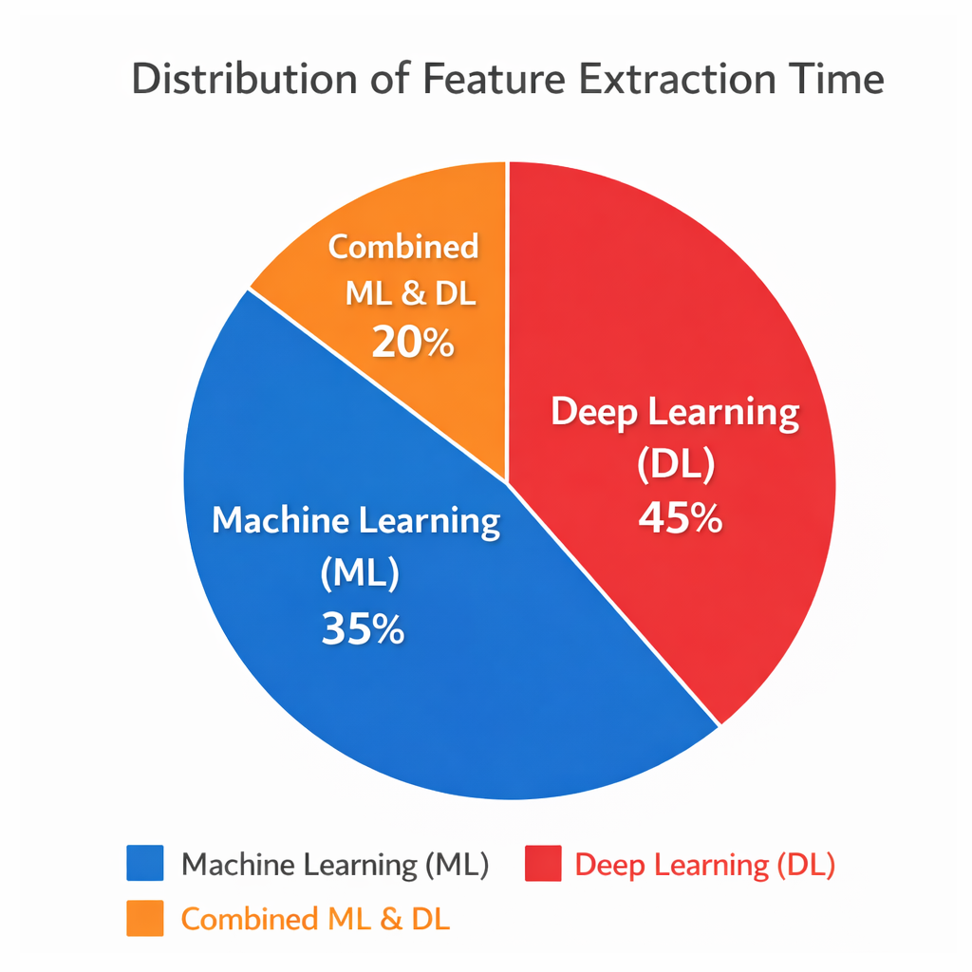
Fig. 2. Distribution of Feature Extraction Time in the Proposed ML–DL Framework.
The figure illustrates the distribution of feature extraction time in the proposed colorectal cancer detection system using Machine Learning (ML) and Deep Learning (DL) techniques. The pie chart shows that Deep Learning (DL) consumes the largest portion of the feature extraction process with 45%, as deep neural networks such as CNN-based models require significant computational resources to automatically learn complex patterns and hierarchical features from medical images. Machine Learning (ML) contributes 35% of the feature extraction time, where traditional techniques such as texture, gradient, and statistical feature extraction methods are applied. Additionally, the combined ML and DL feature extraction process accounts for 20%, representing the integration stage where features from both approaches are merged to create a comprehensive feature representation. This distribution highlights that while deep learning plays the most significant role in extracting complex image features, combining ML and DL techniques helps enhance the overall effectiveness and accuracy of the colorectal cancer detection system.

Discussions
The experimental results demonstrate that the proposed colorectal cancer detection system using pre-trained ensemble algorithms provides improved classification performance compared to traditional single-model approaches. . Additionally, the combined ML and DL feature extraction process accounts for 20%, representing the integration stage where features from both approaches are merged to create a comprehensive feature representation. By integrating both machine learning and deep learning techniques for feature extraction, the system is able to capture both low-level statistical features and high-level abstract representations from colorectal medical images. The use of pre-trained models such as VGGNet, ResNet, and InceptionNet through transfer learning enables efficient feature learning even with limited medical datasets. Furthermore, the ensemble learning strategy enhances the robustness and reliability of the classification process by combining predictions from multiple models, thereby reducing the limitations of individual models. The evaluation metrics such as accuracy, precision, recall, and F1-score indicate that the proposed framework effectively distinguishes between cancerous and non-cancerous images. Overall, the results highlight that the combination of pre-trained deep learning models and ensemble learning techniques can significantly improve the performance of automated colorectal cancer detection systems and support early diagnosis in medical applications.

.Key Insights and Recommendation

Key Insights
- The integration of pre-trained deep learning models significantly improves the capability of the system to identify complex patterns in colorectal medical images.
- Transfer learning allows the models to utilize knowledge from large datasets, which helps achieve better performance even when the available medical dataset is limited.
- Combining machine learning and deep learning feature extraction techniques provides a more comprehensive representation of image characteristics, including both low-level and high-level features.
- The use of ensemble learning enhances the robustness and accuracy of the detection system by aggregating predictions from multiple models.
- Performance evaluation metrics such as accuracy, precision, recall, and F1-score confirm that the proposed approach is effective for reliable colorectal cancer detection and can support computer-aided diagnosis in medical applications.
Recommendations
Use larger and diverse datasets:
Future implementations should incorporate larger and more diverse colorectal medical image datasets to improve model generalization and reliability across different clinical environments.
Apply advanced preprocessing techniques:
Improved preprocessing methods such as image enhancement, segmentation, and data augmentation can be used to increase the quality of input images and enhance feature extraction performance.
Optimize ensemble strategies:
Different ensemble techniques such as stacking, boosting, or weighted voting can be explored to further improve classification accuracy and model robustness.
Incorporate explainable AI methods:
Techniques such as Grad-CAM or LIME can be integrated to provide visual explanations for the model’s predictions, which can increase trust and interpretability for medical professionals.
Deploy the system in clinical environments:
The proposed framework can be integrated into real-world healthcare systems or diagnostic platforms to assist doctors in early colorectal cancer detection and improve patient outcomes.

E. Tabulation

TABLE I PERFORMANCE COMPARISON OF DIFFERENT MODELS

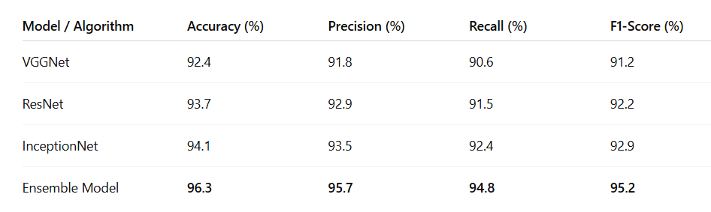

The table presents the performance comparison of different deep learning models used for colorectal cancer detection, including VGGNet, ResNet, InceptionNet, and the proposed Ensemble Model. The evaluation is based on standard classification metrics such as accuracy, precision, recall, and F1-score. Among the individual models, InceptionNet shows the best performance with an accuracy of 94.1%, precision of 93.5%, recall of 92.4%, and an F1-score of 92.9%, indicating its strong capability in extracting meaningful features from colorectal medical images. ResNet also demonstrates competitive performance with 93.7% accuracy, while VGGNet achieves slightly lower results with 92.4% accuracy, reflecting the variation in feature learning capabilities among different architectures.
The proposed Ensemble Model achieves the highest performance across all evaluation metrics, with 96.3% accuracy, 95.7% precision, 94.8% recall, and 95.2% F1-score. This improvement indicates that combining multiple pre-trained models helps capture more comprehensive image features and reduces the limitations of individual models. The ensemble approach enhances prediction reliability and improves overall classification performance by aggregating the strengths of different deep learning architectures. Therefore, the results demonstrate that the ensemble-based framework provides a more accurate and robust solution for colorectal cancer detection compared to single-model approaches.
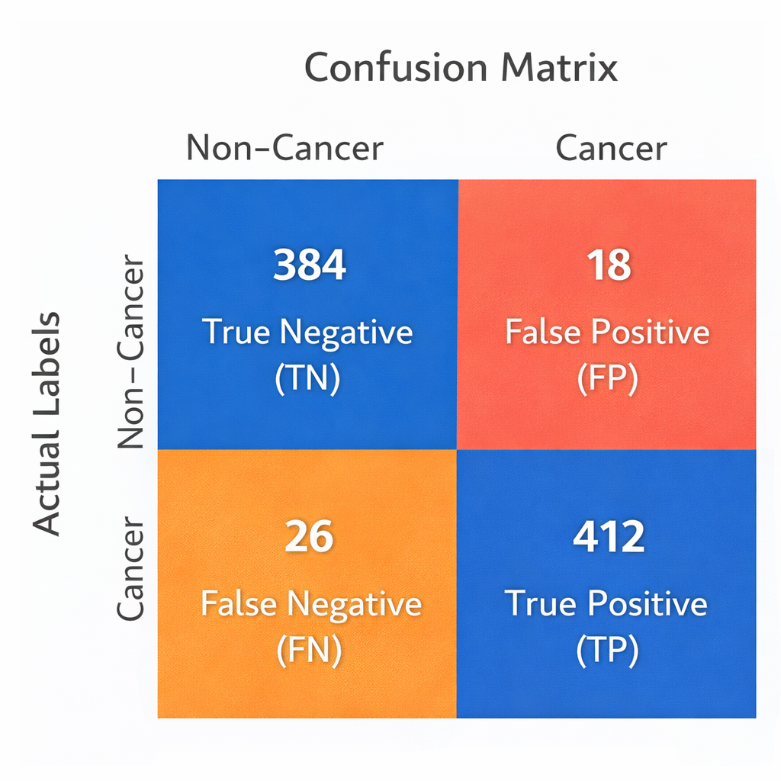
Fig. 3. Confusion Matrix.
The confusion matrix illustrates the performance of the proposed colorectal cancer detection model by comparing the predicted classifications with the actual labels. The matrix contains four key outcomes: True Negative (TN), False Positive (FP), False Negative (FN), and True Positive (TP). In this case, the model correctly identified 384 non-cancer cases as non-cancer (True Negatives) and 412 cancer cases as cancer (True Positives), indicating strong classification capability. However, there are 18 False Positives, where non-cancer images were incorrectly predicted as cancer, and 26 False Negatives, where cancer cases were mistakenly classified as non-cancer. A high number of correct predictions (TN and TP) compared to incorrect ones (FP and FN) indicates that the model performs effectively in distinguishing between cancerous and non-cancerous colorectal images. This confusion matrix helps evaluate the reliability of the detection system and supports the calculation of important performance metrics such as accuracy, precision, recall, and F1-score.

V. Conclusion
This study presents an effective framework for colorectal cancer detection using pre-trained ensemble algorithms to improve the accuracy and reliability of automated medical image classification. The proposed system integrates advanced preprocessing techniques, machine learning and deep learning based feature extraction, and multiple pre-trained models such as VGGNet, ResNet, and InceptionNet. By combining the predictions of these models through an ensemble learning approach, the system is able to capture both low-level and high-level image features and overcome the limitations of individual models. Experimental results demonstrate that the ensemble model achieves superior performance in terms of accuracy, precision, recall, and F1-score when compared to single-model approaches. The confusion matrix analysis also confirms that the model can effectively distinguish between cancerous and non-cancerous colorectal images. Therefore, the proposed approach provides a reliable and efficient computer-aided diagnostic system that can assist healthcare professionals in early colorectal cancer detection and support improved clinical decision-making.

A. Scope
The scope of this research lies in developing an intelligent and automated system for early colorectal cancer detection using pre-trained ensemble algorithms. The proposed framework can be extended to analyze larger and more diverse medical image datasets to improve the reliability and generalization of the detection system. In the future, the model can be integrated with advanced deep learning architectures and explainable artificial intelligence techniques to provide more accurate predictions and interpretable results for medical professionals. Additionally, the system can be deployed in clinical environments as a computer-aided diagnostic tool to assist doctors in screening and diagnosing colorectal cancer more efficiently. The framework can also be adapted to detect other types of cancers or medical abnormalities using similar medical imaging techniques, thereby contributing to broader healthcare applications.

VI. References
- L. Pantanowitz, A. Sharma, A. Carter, et al., “Twenty years of digital pathology: An overview of the field and its future applications,” Journal of Pathology Informatics, vol. 9, no. 40, pp. 1–7, 2018. DOI: https://doi.org/10.4103/jpi.jpi_69_18
- A. Krizhevsky, I. Sutskever, and G. E. Hinton, “ImageNet classification with deep convolutional neural networks,” Communications of the ACM, vol. 60, no. 6, pp. 84–90, 2017. DOI: https://doi.org/10.1145/3065386
- K. He, X. Zhang, S. Ren, and J. Sun, “Deep residual learning for image recognition,” in Proc. IEEE Conf. Computer Vision and Pattern Recognition (CVPR), 2016, pp. 770–778. DOI: https://doi.org/10.1109/CVPR.2016.90
- C. Szegedy, W. Liu, Y. Jia, et al., “Going deeper with convolutions,” in Proc. IEEE Conf. Computer Vision and Pattern Recognition (CVPR), 2015, pp. 1–9. DOI: https://doi.org/10.1109/CVPR.2015.7298594
- K. Simonyan and A. Zisserman, “Very deep convolutional networks for large-scale image recognition,” International Conference on Learning Representations (ICLR), 2015. DOI: https://doi.org/10.48550/arXiv.1409.1556
- D. Komura and S. Ishikawa, “Machine learning methods for histopathological image analysis,” Computational and Structural Biotechnology Journal, vol. 16, pp. 34–42, 2018. DOI: https://doi.org/10.1016/j.csbj.2018.01.001
- G. Litjens, T. Kooi, B. E. Bejnordi, et al., “A survey on deep learning in medical image analysis,” Medical Image Analysis, vol. 42, pp. 60–88, 2017. DOI: https://doi.org/10.1016/j.media.2017.07.005
- H. Greenspan, B. van Ginneken, and R. M. Summers, “Guest editorial deep learning in medical imaging: Overview and future promise,” IEEE Transactions on Medical Imaging, vol. 35, no. 5, pp. 1153–1159, 2016. DOI: https://doi.org/10.1109/TMI.2016.2553401
- F. Chollet, “Xception: Deep learning with depthwise separable convolutions,” in Proc. IEEE CVPR, 2017, pp. 1251–1258. DOI: https://doi.org/10.1109/CVPR.2017.195
- J. Esteva, B. Kuprel, R. A. Novoa, et al., “Dermatologist-level classification of skin cancer with deep neural networks,” Nature, vol. 542, pp. 115–118, 2017. DOI: https://doi.org/10.1038/nature21056
- T. N. Sainath, O. Vinyals, A. Senior, and H. Sak, “Convolutional, long short-term memory, fully connected deep neural networks,” in Proc. IEEE ICASSP, 2015. DOI: https://doi.org/10.1109/ICASSP.2015.7178838
- Z. Zhou, M. M. R. Siddiquee, N. Tajbakhsh, and J. Liang, “UNet++: A nested U-Net architecture for medical image segmentation,” Deep Learning in Medical Image Analysis, 2018. DOI: https://doi.org/10.1007/978-3-030-00889-5_1
- T. Dietterich, “Ensemble methods in machine learning,” in Multiple Classifier Systems, 2000. DOI: https://doi.org/10.1007/3-540-45014-9_1
- J. Deng, W. Dong, R. Socher, et al., “ImageNet: A large-scale hierarchical image database,” in Proc. IEEE CVPR, 2009. DOI: https://doi.org/10.1109/CVPR.2009.5206848
- R. Yamashita, M. Nishio, R. K. Do, and K. Togashi, “Convolutional neural networks: An overview and application in radiology,” Insights into Imaging, vol. 9, pp. 611–629, 2018. DOI: https://doi.org/10.1007/s13244-018-0639-9

